**Heart Attack**

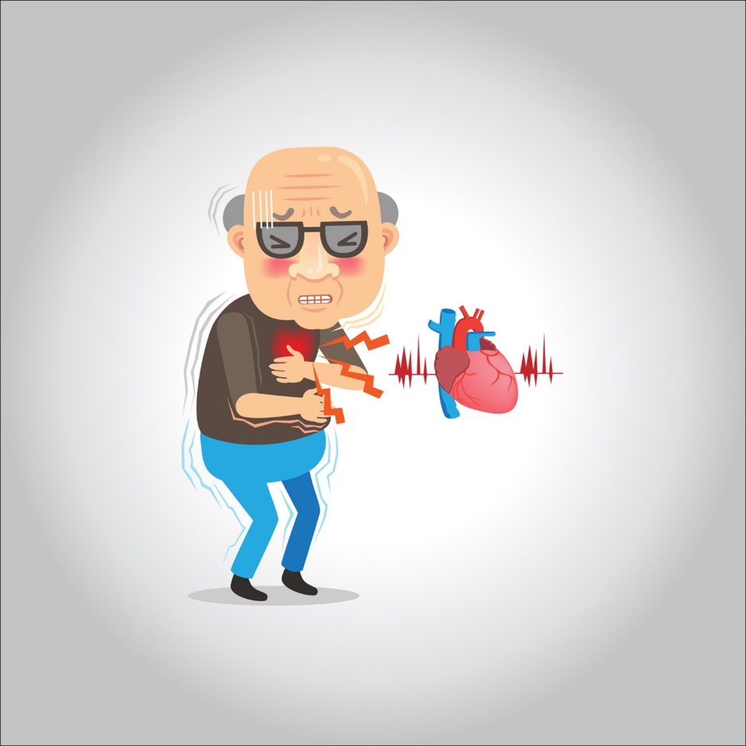

**It is a type of chest pain caused by reduced blood flow to the heart. It is a symptom of coronary artery disease. Angina pectoris, also called angina, is often described as a feeling of pressure, squeezing, heaviness, tightness, or pain in your chest.**

**The reasons**

**Angina pectoris occurs due to reduced blood flow to the heart muscle. Your blood carries the oxygen your heart muscle needs to survive. And when the heart muscle doesn’t get enough oxygen, it causes a condition called ischemia.**

**Coronary artery disease (CAD) is the most common cause of reduced blood flow to the heart muscle. The arteries of the heart (coronary artery) can narrow due to fatty deposits called plaques. This is called atherosclerosis.**

**During times of low oxygen demand — when you’re resting, for example — the heart muscle may still be able to function with a reduced amount of blood flow without causing angina symptoms. But when the demand for oxygen increases, such as when exercising, angina can occur.**

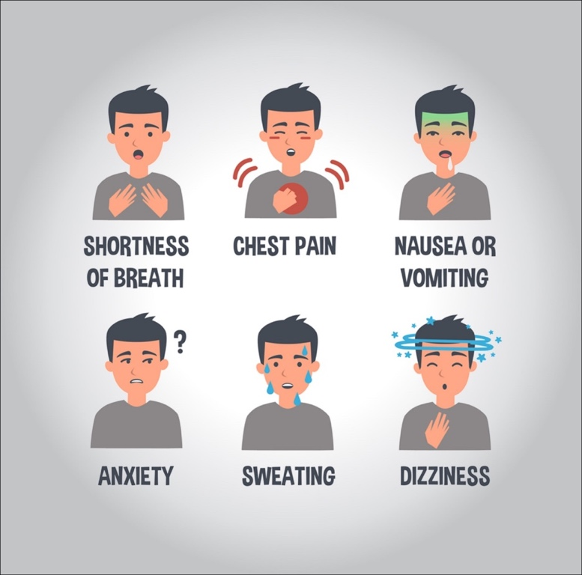

**Stable angina pectoris**

**Stable angina is usually caused by physical exertion. When climbing stairs, exercising, or walking, your heart needs more blood, but narrowed arteries slow blood flow**

**Unstable angina pectoris**

**If fatty deposits (plaques) in a blood vessel rupture or a blood clot forms, they can quickly block or reduce flow through the narrowing of the artery.**

**Prinzmetal’s angina pectoris**

**This type of angina is caused by a sudden spasm of a coronary artery, temporarily narrowing the artery. This narrowing reduces blood flow to your heart, causing severe chest pain**

**Symptoms**

**Symptoms of angina include chest pain and a feeling of tightness that may be described as squeezing, squeezing, burning, or fullness.**

**You may also feel pain in your arms, neck, jaw, shoulder, or back.**

**Other symptoms you may feel when you have angina include:**

**Vertigo**

**Exhaustion**

**Nausea**

**Shortness of breath**

**Sweating**

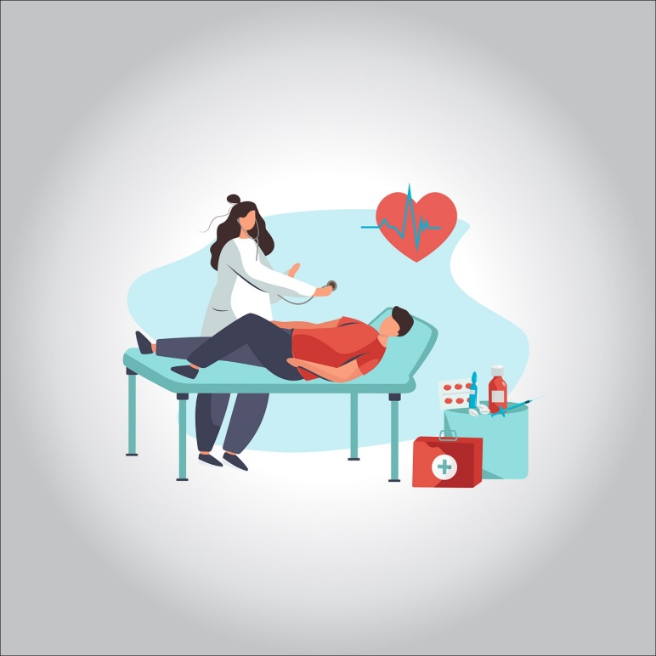

**Risk factors**

**Smoking**

**Diabetic**

**Hypertension.**

**High levels of cholesterol or triglycerides in the blood.**

**A family history of heart disease**

**Getting old**

**Lack of exercise**

**Obesity**

**Stress**

**Complications**

**Feeling of pressure, fullness, or pain in the middle of your chest that lasts more than a few minutes**

**The pain extends beyond your chest to your shoulder, arm, back, or even your teeth and jaw**

**Increased episodes of chest pain**

**Vomiting and nausea**

**Constant pain in the upper abdomen**

**shortness of breath**

**Sweating**

**Fainting**

**The feeling of impending doom**

**Protection**

**You can help prevent angina by making the same lifestyle changes that may improve symptoms if you already have angina. Including:**

**Quit Smoking.**

**Monitor and control other health conditions, such as high blood pressure, high cholesterol, and diabetes.**

**Eat a healthy diet and maintain a healthy weight.**

**Increase your physical activity with your doctor’s approval.**

**Aim for 150 minutes of moderate activity each week.**

**In addition, it is recommended that you do 10 minutes of strength training twice a week and do stretching three times a week for five to 10 minutes each time.**

**Reduce your stress level.**

**Limit alcohol consumption to two or fewer drinks per day for men, and one or less per day for women.**

**Get an annual flu shot to avoid heart complications from the virus.**

**Treatment**

**Aspirin; Aspirin reduces the blood’s ability to clot, making it easier for blood to flow through narrowed heart arteries**

**Anticoagulant drugs.**

**Beta blockers**

**Cholesterol-lowering drugs.**

**Calcium channel blockers.**

**Antihypertensive drugs.**

**Ranolazine (Ranexa)**